OADD- RSIG Abstract

**TRAINING FROM A DISTANCE: AN EVALUATION OF A TELECOMMUNICATION COMPETENCY-BASED MODEL OF STAFF TRAINING.**

**Joey Robertson1, Kendra Thomson1, Mary Hume2, Carly Magnacca1, Amanda Marcinkiewicz1, & Jessica Cauchi2**

**1Brock University, 2 Atlas Behaviour Consultation**

**Objective:** Telecommunication models (TCMs) have been shown to increase the accessibility of effective behavioural services for children with autism spectrum disorder (ASD). Behavioural skills training (BST) is an evidence- and competency-based model with preliminary efficacy for training staff when delivered through TCM. Further evaluation is needed to assess generalization of trainee outcomes to clinical settings and untrained procedures, while measuring the corresponding effects of the training on child outcomes. The purpose of this study was to assess the efficacy of BST via TCM (TCM-BST) for training behaviour technicians on specific behavioural protocols. Additionally, the study aimed to assess the generalization of the training with a similar (untrained) skill, with a child with ASD, and the effects of staff implementation on child outcome measures.

**Methods:** A concurrent multiple-probe design across three staff/child dyads was used to evaluate the efficacy of training staff using TCM-BST. The current study involved 3 female behaviour technicians with less than 6 months of work experience at Atlas Behaviour Consultation. Additionally, 3 children aged 5-7 years old (*M* = 6.3 years) with diagnosis of ASD were recruited and paired with a staff. Outcome measures included: staff accuracy when implementing the target procedure (e.g., errorless learning) and a similar, untrained procedure (e.g., paired stimulus preference assessment) when teaching both a confederate and child with ASD. Child outcomes were measured as percent correct performance on programs staff taught with the target procedure (i.e., errorless learning), as outlined in the child’s programming.

**Results:** Results to date indicate that following training on the target skill (errorless learning), all three staff showed improved implementation accuracy with a confederate (average increase of 23.1% from baseline). One of three participants generalized their performance on the target skill with the child, which lead to an increase in the child’s correct responding (mean increase of 35% from baseline). Two of three staff did not show an increase in implementation accuracy of the untrained skill (e.g., paired stimulus) following training of the target skill. Data collection is ongoing to assess the impact of a in vivo coaching phase and maintenance one-month post-training.

**Discussion/Conclusion:** This presentation will elaborate on the results, review the advantages of adding a TCM coaching phase, and discuss the potential impacts of TCM for training individuals in how to provide behavioural services in Ontario.

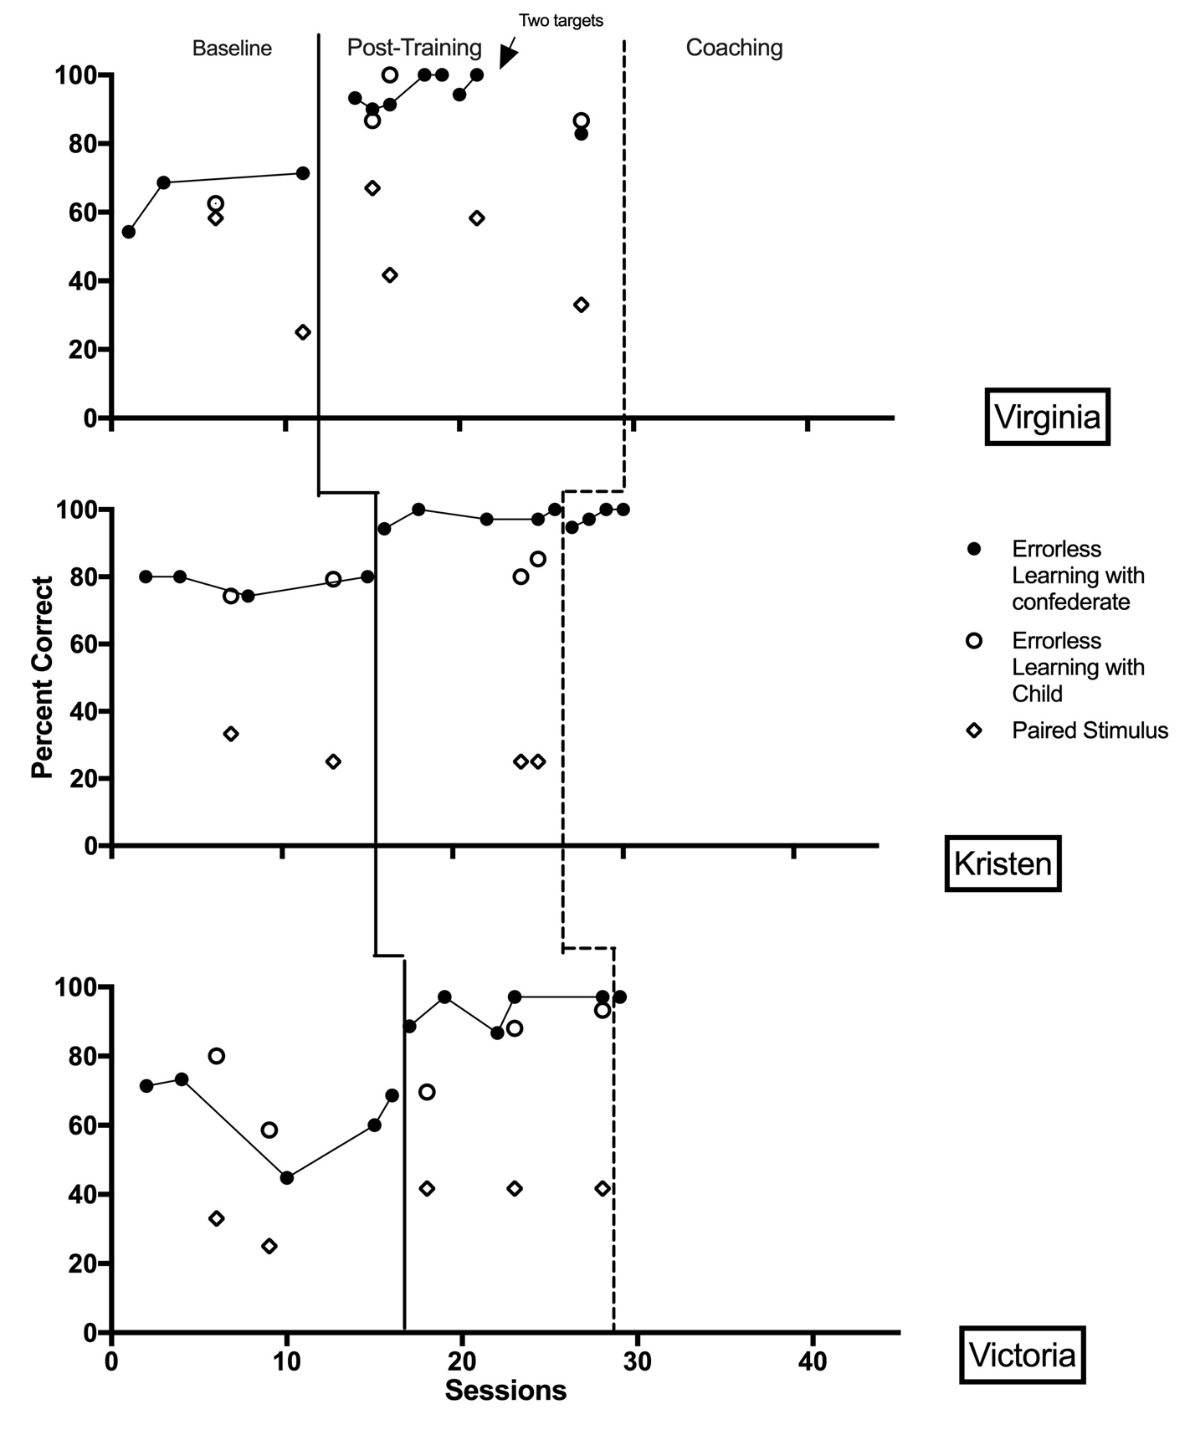

*Figure 1.0.* Implementation accuracy of three behaviour technicians on: the target skill (errorless learning) with a confederate roleplaying a child with ASD (closed circles) and with a child with ASD (open circles), and the untrained skill (paired stimulus preference assessment) with a child with ASD (open diamonds).

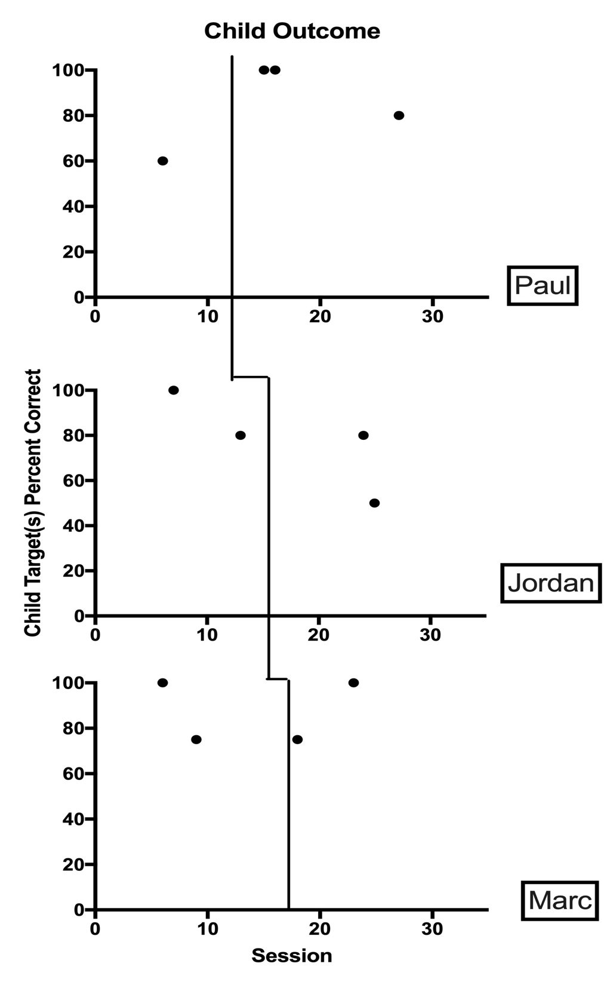

*Figure 1.1.* Child outcome measures for three children with ASD. Targets were chosen from the children’s individualized behavioural programming and included: typing program (Paul), receptive identification of item features, function and class and cutting program (Jordan), and associations and “w” questions (Marc).